Scholarship Opportunities
The Alpha Kappa Educational Foundation, along with many donor advised funds held at
Missouri S&T, the Miner Alumni Association, and the PiKA Memorial Headquarters, annually awards over $100,000 in scholarships to members of the Alpha Kappa chapter of Pi
Kappa Alpha at Missouri S&T. Scholarships include the three scholarships below as well as numerous other scholarships ranging from $100 up to $2500 based on financial need, campus involvement, athletic performance, community service, and fraternity participation. More information about these scholarships can be provided upon request.

Scholastic Scholarship
Awards are based on semester GPA at the following three levels: Level 1: 3.8-4.0 receives $350, Level 2: 3.5-3.79 receives $300, and Level 3: 3.2-3.49 receives $150.

Leadership Scholarship
In regard to executive leadership, the Alpha Kappa leadership team is eligible to receive awards based on achievement of semesterly performance objectives. The amounts for each office range from $500-$1000.

Vernon A.C. Gevecker Memorial Scholarship
Sometimes referred to as the rush scholarship, the Gevecker award focuses on new members entering their first year of enrollment at MS&T where award criteria reflects academic merit, extra-curricular involvement, leadership, and character demonstrated in high school. Typically, four recipients are chosen annually at $250 each.
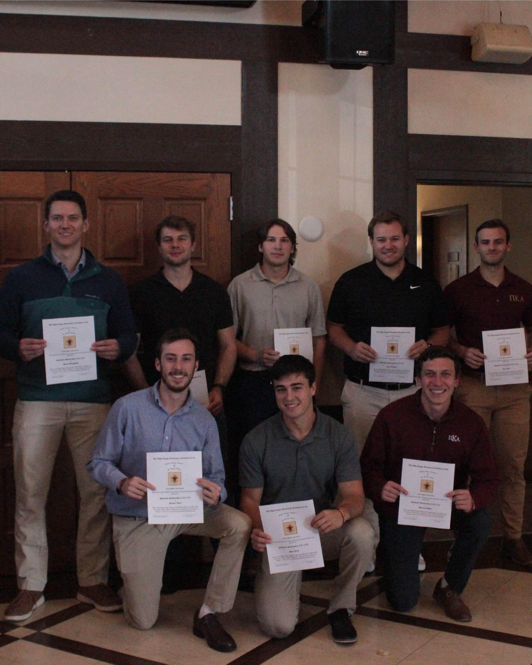


The Alpha Kappa Scholarship Program started in 1952 with a donation from Enoch R. Needles of $1,000. Since that time, the program has been transformed into the Alpha Kappa Educational Foundation through contributions from various sources. The Alpha Kappa Educational Foundation is a tax-deductible 501(c)(3) organization. Today, over $100,000 dollars are awarded annually to the members of Pi Kappa Alpha at Missouri S&T to recognize their accomplishments, and to inspire achievement of the higher ideals set forth by the founders in the Preamble.

